BÀI DẠY ONLINE TUẦN 13,14 KHỐI 6
(29/11 – 12/12/2021)
TUẦN 13: (29/11 – 5/12/2021) + TUẦN 14: (6/12 -12/12/2021)
UNIT 4: FESTIVALS AND FREE TIME

A. VOCABULARY (TỪ VỰNG)
Lesson 3
No | Words |  | Transcription | Meaning
18 | buy | (v) | /baɪ/ | Mua
19 | candy | (n) | /ˈkændi/ | Kẹo
20 | decorate | (v) | /ˈdekəreɪt/ | Trang trí
21 | fireworks | (n) | /ˈfaɪərwɜːrk/ | Pháo hoa
22 | flower | (n) | /ˈflaʊər/ | Hoa
23 | fruit | (n) | /fruːt/ | Hoa quả
24 | gift | (n) | /ɡɪft/ | Quà tặng
25 | lucky money | (n) | /ˈlʌki ˈmʌni/ | Tiền lì xì
26 | parade | (n) | /pəˈreɪd/ | Buổi diễu hành
27 | traditional | (adj) | /trəˈdɪʃənl/ | Truyền thống
28 | visit | (v) | /ˈvɪzɪt/ | Thăm, tham quan

Further words
No | Words |  | Transcription | Meaning
29 | hopscotch | (n) | /ˈhɑːpskɑːtʃ/ | Trò chơi ô lò cò
30 | wrestling | (n) | /ˈreslɪŋ/ | Môn đấu vật
31 | martial | (adj) | /ˈmɑːrʃl/ | Hùng dũng
32 | basketball | (n) | /ˈbæskɪtbɔːl/ | Bóng rổ
33 | overseas | (adj) | /ˌəʊvərˈsiːz/ | Hải ngoại

B. EXERCISE (BÀI TẬP)
I. Choose the words whose underlined part is pronounced differently from that of the others in each group.
1. A. special B. celebrate C. excited D. center
2. A. Thanksgiving B. thinking C. there D. thin
3. A. positive B. negative C. tug D. future
4. A. puppet B. funny C. schedule D. sunny
5. A. milk-shake B. fashion B. talent C. candy
6. A. town B. flowers C. show D. cow
7. A. celebrates B. foods C. fireworks D. points
8. A. festivals B. weekends C. Saturdays D. gifts
9. A. activities B. timetables C. performances D. roles
10. A. decorated B. watched C. worked D. danced

II. Choose the word whose main stressed syllable is placed differently from that of the other in each group.
11. A. market B. puppet C. parade D. magic
12. A. excite B. costumes C. lantern D. martial
13. A. festivals B. decorate C. important D. family
14. A. location B. apartment C. tradition D. Halloween
15. A. restaurant B. traditional C. participate D. activity

III. Use the given words to label the picture.
watch fireworks | decorate a house or tree | watch parades
eat traditional foods | get lucky money, candy, or gifts | watch Korean wrestling
visit family and friends | play games or music | buy fruits or flowers

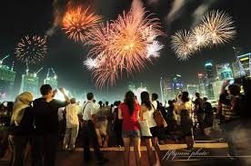 | 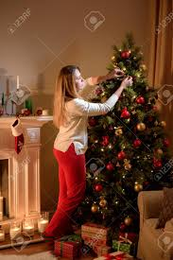 | 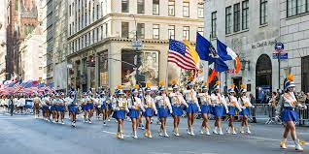
1. | 2. | 3.
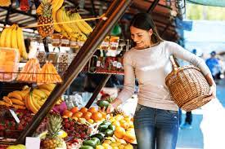 |  | 
4. | 5. | 6.
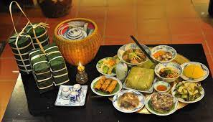 | 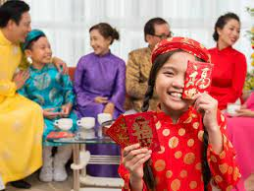 | 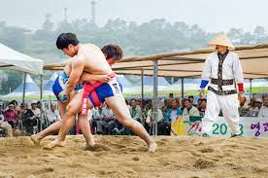
7. | 8. | 9.

IV. Fill in the blanks with the words from the box.
get lucky money | rarely | fireworks | always
talent show | eat traditional foods | food stands | never

1. I rarely eat fast food. I don't like the taste and it often makes me sick.
2. My favorite part about Tết is to____________________. I usually use it to buy new books.
3. I think you should participate in the____________________. You can dance really well.
4. Mary____________________ waters her flowers before going to school. She waters them every morning.
5. I want to check out the____________________. All the dishes look very tasty.
6. Let's watch____________________ together. My mom lets us stay up late and you can sleep at my apartment.
7. We____________________ go out after eight. My dad doesn't think it's safe.
8. We____________________ such as stollen, a special cake, on Christmas Day.

V. Write sentences using the words below.
1. We/ decorate/ houses/ Halloween.
………………………………………………………………………………………………………………………………………
2. John/ sometimes/ play video games/ his friends/ after school.
………………………………………………………………………………………………………………………………………
3. fashion show/ start/ 8 p.m.
………………………………………………………………………………………………………………………………………
4. How/ people/ prepare/ Christmas?
………………………………………………………………………………………………………………………………………
5. How/ often/ you/ go shopping?
………………………………………………………………………………………………………………………………………
6. bus/ leave/ 10 a.m.
………………………………………………………………………………………………………………………………………
❹READING
I. Read the article and choose the A, B, C for each question.
SUMMERFUN
Tyler Jacobs, February 10
I love going to different festivals. I went to a great festival in my town last week called SummerFun. They hold so many great things there. There were lots of stands selling traditional foods and drinks. I ate so much. They also had lots of shows. I watched the fashion show and the talent show. I didn't have time to watch the puppet show, and I think puppets are boring. My friend, Jane, and I did the lug of war. We lost but it was still fun. My favorite thing was the music performance at the end. It wasn't Jane's favorite, though. Hers was the talent show. I can't wait for next year's festival. I'm going to bring all my friends.
1. Where was the festival?
A. Sumer Town B. Tyler's town C. a local park
2. What did they not have at the festival?
A. food stands B. flower show C. a puppet show
3. What did Tyler not watch?
A. a fashion show B. a talent show C. a puppet show
4. What was Tyler favorite thing?
A. the music performance B. the talent show C. the tug of war
5. What was one favorite thing?
A. the fashion show B. the talent show C. the music performance

II. Read the article and answer the questions.
A Famous Festival in Vietnam
In Vietnam, people celebrate many different festivals each year. The biggest festival in Vietnam is Tết. This celebrates the beginning of the Lunar New Year. Vietnamese people have to prepare a lot for this festival. Before Tết, people buy fruits and flowers from the market and decorate their houses. Most people buy a special tree with lots of flowers. In the north of Vietnam, people buy peach trees with pink flowers. In the south, people buy apricot trees with yellow flowers. Everyone cleans their house before Tết. This is very important because you shouldn't clean it during Tết. During Tết, people visit their family and friends. Few people go to school or work. Children wear new clothes and get lucky money. It's a great time to watch lion dances and fireworks. Everyone is happy and excited about the New Year. Vietnamese people love to celebrate this festival.

Questions:
1. Do people celebrate many different festivals each year?
………………………………………………………………………………………………………………………………………
2. Is Tết the biggest festival in Vietnam?
………………………………………………………………………………………………………………………………………
3. What do people often do before Tết?
………………………………………………………………………………………………………………………………………
4. What do people often do during Tết?
………………………………………………………………………………………………………………………………………
5. In the North of Vietnam, what type of tree do people buy?
………………………………………………………………………………………………………………………………………
6. In the South of Vietnam, what type of tree do people buy?
………………………………………………………………………………………………………………………………………
❺ WRITING
I. Write sentences using the words given.
1. dance performance/ start/6 p.m./end/ 7 p.m.
………………………………………………………………………………………………………………………………………
2. talent show/ start/ 11 a.m./end/ at 1 p.m.
………………………………………………………………………………………………………………………………………
3. music performance/ start/ 6 p.m./end/ 8 p.m.
………………………………………………………………………………………………………………………………………
4. tug of war/ start/ 2 p.m./end/3 p.m.
………………………………………………………………………………………………………………………………………
II. Write a text message about Christmas using the given information.
- one of the biggest traditional holidays in the UK
- families get together
- give gifts and cards to family members and friends
- have a special meal
- play games after the meal
Hi, Ben. Are you having a good holiday?
Let me tell you about Christmas.
……………………………………………………………………………………………… ……………………………………………………………………………………………… ……………………………………………………………………………………………… ……………………………………………………………………………………………… ……………………………………………………………………………………………… See you

